**OPTIMIZATION**

**On multiple variables.**

Topics covered:

* Multidimensional spaces
* Partial derivatives
* Gradients
* Optimization with gradients

In real Machine Learning our data is multi-dimensional, meaning we will be optimizing

Multiple variables.

So we remember that in 2D (with parabolas, hyperbolas etc.) we were finding the point of minimal derivative (tangent line with slope of 0).

In 3D and nD we do pretty much the same.

But instead of tangent line we have tangent plane

Here’s an illustration:

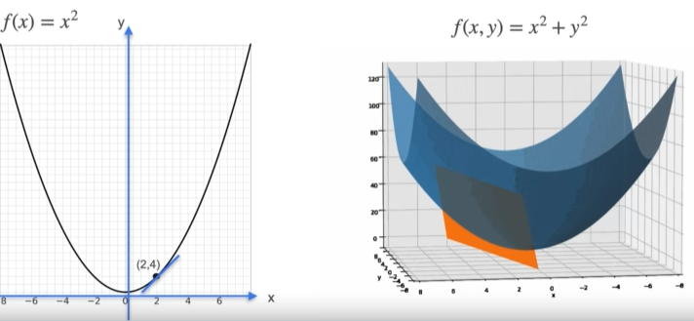

But how do we find this tangent plane?

Easy.

Plane can be constructed from 2 lines (like a kite)

And those 2 lines are tangent lines.

We simply need to find *partial derivative*.

But what’s that?

As our function takes 2 arguments (*x* and *y*)

We can fill one of the values by some random constant.

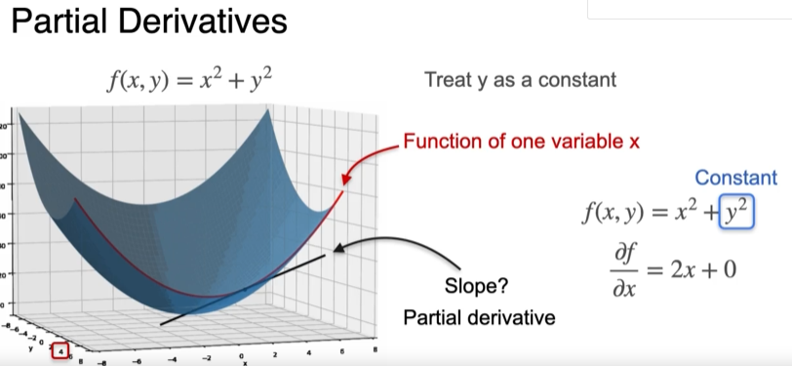

On this picture this constant is y=4, but it doesn’t matter as derivative of const = 0

(it doesn’t change)

So we get one tangent line.

We do the same thing with x=const.

Btw it is called:

or

Where we leave or mentioned value untouched and replace other one (y for 1st and x for 2nd example) with constant.

If we know what a partial derivative is and how we calculate the tangent plane we know what **Gradient** is.

Gradient is one of the most fundamental concepts in Machine Learning, but frankly speaking it’s just a vector of partial derivatives.

This vector is n-1 dimensional and it can be used to apply optimizations.

If you have ever worked with Tensorflow Keras you should know about gradients applying.

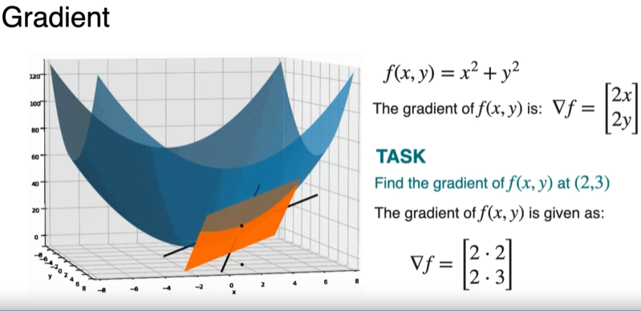

Gradients are displayed with ⛛ sign.

Optimization with gradients is not complicated at all.

We just set each gradient value (as gradient value is a simplified derivative formula)

To 0 and solve this equation.

Alright. That’s pretty much it.

I told all I wanted (and all I knew).

So tomorrow paper will be modified (I believe)

________________________________________

This material is free to use, share, and criticize.

Uses materials by DeepLearningAI

DeepLearningAI course - [link](https://www.coursera.org/specializations/mathematics-for-machine-learning-and-data-science)

Written by Venchislav for the GitHub community❤.

21.03.2024

_____________

GoodBye!